Data Type Tree in C#

Lane Dorscher
CS300-T301 Programming Languages (2261-1)
Bellevue University
11/02/2025
Ahmad Mostafa

Introduction
This paper will examine how programming language data types can be represented as tree structures and how structural equivalence of these types can be determined using recursive algorithms. The paper will explore the use of C# to model types as trees and will describe methods to handle both standard and recursive types. Additionally, it will demonstrate a process to check if two types are equivalent structurally, including strategies to manage self-referential or recursive definitions commonly found in linked lists and other recursive structures. The thesis of this paper is that representing data types as trees allows for efficient type comparison and accurate handling of complex structures in programming languages, which is critical for tasks such as compiler design, type checking, and software verification. This exploration will provide insight into how type systems can be modeled in object-oriented languages and will present pseudocode that illustrates practical implementation (Pierce, 2002).

Representing Types as Trees
Type Node Structure
Types can be expressed as tree structures in which each node represents a primitive type or a type constructor like struct, array or pointer. Each node contains information about its kind. This includes relevant metadata like array size as well as any children nodes that may be owned by the parent Node. Below is an example written in C# to represent how this would be structured. The variable string “Kind” tells us what it is: int, double, struct, array, pointer. The “Children” variable is for the different nodes belonging to this one varying different primitive type nodes or another kind of node. Finally, the “Size” variable is used for array Kind of node to indicate its size as the name suggests. Using -1 when it’s not applicable. This idea aligns with how types are modeled in programming language theory and type systems (see Pierce, 2002).
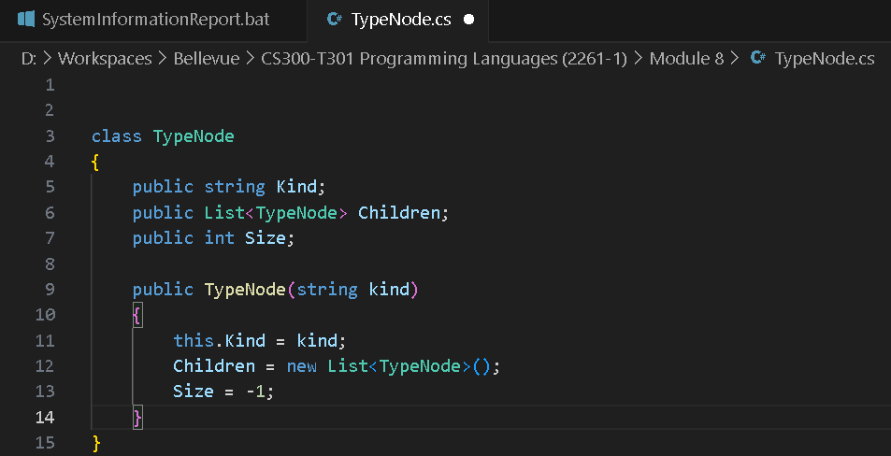

Structural Equivalence
To determine if two types are structurally equivalent, a recursive function can traverse the type tree and compare each node’s kind, array size, and children. For non-recursive types, the function is as follows:
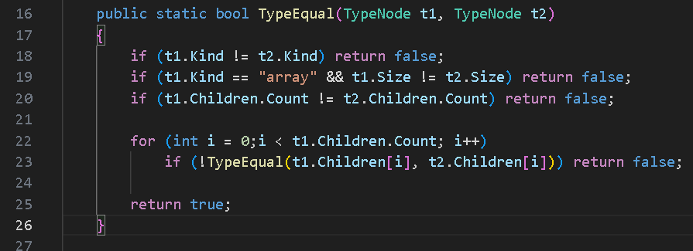
This approach ensures that each component is compared recursively to maintain accuracy in the structural equivalence check. The children of t1 must match the children of t2 in the same order to be considered structurally equal.

Handling Recursive Types
Recursive Type Representation
A recursive type is a data type that refers to itself, either directly or indirectly. A common example is a linked list where each node contains a value and a pointer to another node of the same type. In C#, a simple linked list node could conceptually be represented as a struct or class containing an integer field and a reference to the next node. From the perspective of the type tree, a TypeNode would have a value field (like integer) and a next field with a pointer or reference back to the same type node creating that recursive reference (Pierce, 2002).
To handle these safely in a way that prevents an infinite loop, we can pass a set that contains what has been previously visited. In the screenshot below, the code written in C#, has been given an extra parameter to the TypeEquals method called “visited” which is a HashSet that will contain forever unique sets of pairs previously evaluated. It was given a default parameter which will initialize it to null. The syntax visited ??= new HashSet<(TypeNode, TypeNode)>(); is a null-coalescing assignment operator which checks if visited is null and if so, assigns it a new HashSet object (Microsoft, n.d.). The user will not have to explicitly set a HashSet object but ensures it’s created for recursive checks during the cycles. This method ensures that cyclic structures do not cause infinite recursion while maintaining correct equivalence checking.
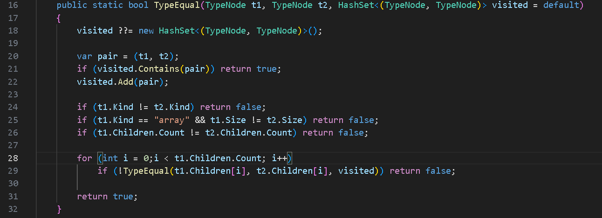

Conclusion
The examination of representing programming language types as trees demonstrates that structured type modeling allows for efficient and accurate type comparisons. Implementing C# classes for type nodes and recursive equivalence checking provides a clear, practical method to manage both standard and recursive types. Using visited sets effectively handles cycles, which are common in recursive structures like linked lists. The strategies described in this paper have illustrated how tree representations can facilitate compiler design and type-checking processes, ensuring reliable handling of complex data types.

References
Microsoft. (n.d.). ?? and ??= operators — the null-coalescing operators. Microsoft Learn. https://learn.microsoft.com/en-us/dotnet/csharp/language-reference/operators/null-coalescing-operator
Pierce, B. C. (2002). Types and programming languages. MIT Press.

